American GlassCrafters Internal Application

Purpose
The purpose of this guide is to document the current state of AGC internal application. It includes menu and screen shots, database tables, and relationship between screen data and database tables.

Database

General information
Currently data is stored in SQL Server 2008 R2 database. It has no foreign keys or indexes besides those related to primary keys. Additional work will be done at a later date to rectify the issue.

Tables
- ApCGBatchVendorInvoice
- ApCGImportInvoice
- ApCGImportInvoiceHdr
- Common
- Company
- OEAddress
- OEARAgedBalance
- OEARAgedDetail
- OeBillMaterials
- OeBOM2
- OEChargeItemList
- OeCollectCall
- OEContractor
- OECustCont
- OeCustDisc
- OECustomer
- OeCustReSaleCert
- OECustSales
- OeCustSalesRep
- OEEmail
- OEEmpMaster
- OEFinishGroup
- OEHandleDef
- OeHandleFinish
- OeHandleSize
- OeInvCountDtl
- OeInvCountHdr
- OeInvCountQTOH
- OEItemTrack
- OEJDEmpAssign
- OEJDHandle
- OEJLDisclaimer
- OEJLHPreMeasure
- OEJobDetailDates – table contains 3 records dated 2008. Is this still used?
- OEJobLogDates
- OEJobLogDetail – table contains 2 records dated 2008. Is this still used?
- OEJobLogHeader
- OeJobLogInvDtl
- OEJobLogPrice – table contains 9 records dated 2008. Is this still used?
- OEJobLogText
- OeJobLogWO
- OeJobLogWOHdr
- OeJobOrderDates
- OeJobOrderOpening
- OeJobOrderPrcWH
- OeJobOrdRmLocation
- OeJOGroup
- OeJOProdOrder
- OELeadCustomer
- OeLogOrderGlass
- OeLogOrderGlass2
- OeLogOrderGlassH
- OeLogOrderGlassR
- OeLogOrderGlassT
- OeLogOrderManifest
- OEMCHandle
- OeMedCabDef
- OEModelCategory
- OEModelConfig
- OEModelInstallPrice
- OePartIdPricing
- OePartLocation
- OePartMaster
- OEPhone
- OePODetailP2
- OePOHeader
- OePOReceive1
- OePriceCalculation
PK → PcLogNumber, PcOrderNo, PcSerialNo, PcLineNo
PcPriceType → Common.CmInt (CmKey = 'QtePrcType')
Other columns: PcSeries, PcOtherType, PcDateEffective, PcDescription, PcPrice, PcPartId.
- OePriceControlTable
PK → PtSeries, PtGroupNo
PtPriceGridNo → OePriceGridModel.PdPriceGridNo
PtPriceGridNo2 → OePriceGridModel.PdPriceGridNo
PtFinishGridNo → OePriceGridFinish.PfFinishGridNo
PtHandleGridNo → OePriceGridHandle.PhHandleGridNo
PtMiscGridNo → OePriceGridMisc.PxMiscGridNo
PtMDIGridNo → OePriceGridMDI.PiMDIGridNo
Other Columns: PtControlDescription, PtPricingApproved
- OePriceGridFinish
- OePriceGridHandle
- OePriceGridMDI
- OePriceGridMisc
- OePriceGridModel
PK → PdSeries, PdPriceGridNo, PdDateEffective, PdGlassType, PdHeigth, PdWidth, PdWidth2
- OePriceGroupConfig
PK → PgSeries, PgGroupNo, PgConfigCode, PgVersionNo
As of 9/1/2014, there are 2799 records in the table. There are 393 distinct configuration codes, 143 distinct combinations of series+group, 564 distinct combinations of series+group+version. Single config code may correspond to several series or series+group combinations. Example – DP_HR1B_HDHD can be either Majestic or Epic Hinged.
Some codes for PgSeries (Common.CmKey='MC_Series'): 1 – Majestic, 2 – Epic, 4 – Matrix, 12 – Royal, 14 – Epic Hinged.
- OEProblemLog
- OESalesLeads
- OeShippingLabel
- OESpiffDtl1
- OESpiffDtl2
- OESpiffGiftInv
- OESpiffHdr
- OeStockglass
- OeStockSliderDef
- OEStopNo
- OeTaxCodeRate
- OeVendDamMaterial
- OeVendGlsBreakdown
- OeVendGlsCost
- OeVendor
- OeVendXref
- QbCustomer
- QBCustParent
- QBCustPending
- QBCustTaxCode - the table is empty
- QBTransaction
- QBVendPending
- QpReceivePaymentLine
- QsSalesLine
- ShippingStatuses
- SyWhoIsSignedOn
- Users
UsUserID | nvarchar(20), PK, NN
UsEmployeeNo | smallint, NN
UsUserPassword | nvarchar(20), NN
UsUserType | nvarchar(20), NN | Values: UnRestricted, Restricted. Only 2 accounts are restricted – Install and Measure
- VendorPartXref

Menus

File

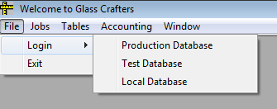

The following databases can be selected (source: frmMDIMain.frm):
Title | Production | Test | Local
Server | EDGE_SERVER | I was not able to locate DB info | JOEG-PC\SQLEXPRESSLOCAL
DB | GCProduction | I was not able to locate DB info | GCProduction
DSN | GCProduction | I was not able to locate DB info | QBLocal

Jobs
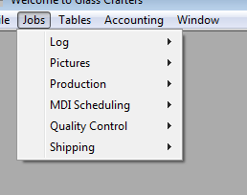
Jobs menu contains the following menu options: Log, Pictures, Production, MDI scheduling, Quality Control and Shipping

Log
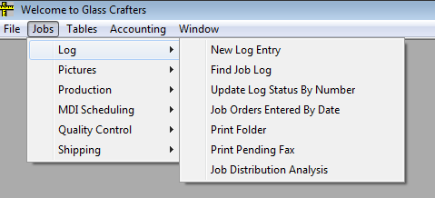
Invoked screens:
- New Log Entry
- Find Job Log
- Update Log Status By Number
- Job Orders Entered By Date
- Print Folder
- Print Pending Fax
- Job Distribution Analysis

Pictures
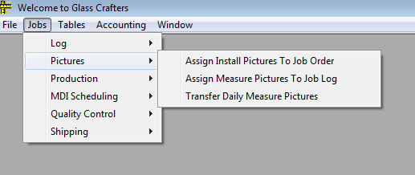
Invoked screens:
- Assign Install Pictures To Job Order
- Assign Measure Pictures To Job Order
- Transfer Daily Measure Pictures

Production
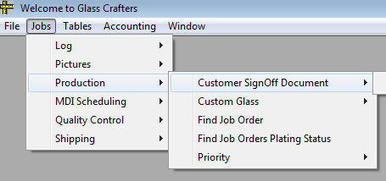
Invoked screens:
- Find Job Order
- Find Job Orders Plating Status

Customer SignOff Document
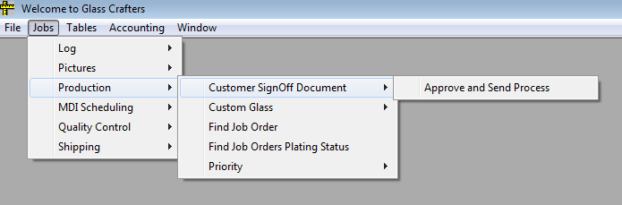
Invoked screen:
- Approve and Send Process

Custom Glass
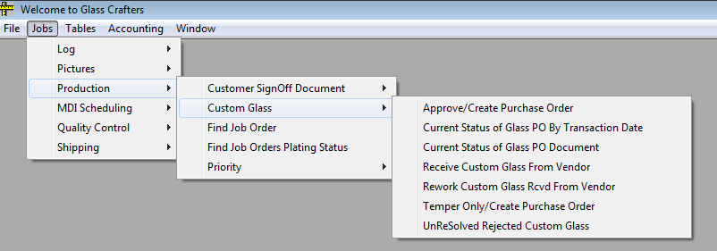
Invoked screens:
- Approve/Create Purchase Order
- Current Status of Glass PO By Transaction Date
- Current Status of Glass PO Document
- Receive Custom Glass From Vendor
- Rework Custom Glass Rcvd From Vendor
- Temper Only/Create Purchase Order
- UnResolved Rejected Custom Glass

MDI Scheduling
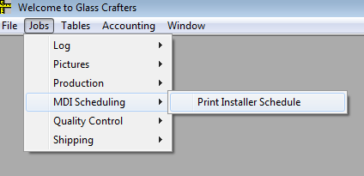
Invoked screens:
- Print Installer Schedule

Quality Control
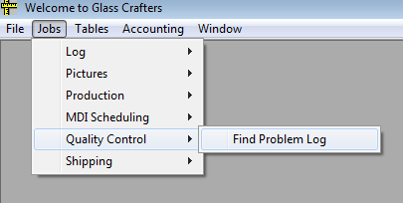
Invoked screens:
- Find Problem Log

Shipping
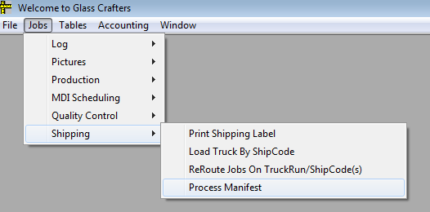
Invoked screens:
- Print Shipping Label
- Load Truck By ShipCode
- ReRoute Jobs on TruckRun/ShipCode(s)
- Process Manifest

Tables

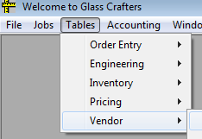
Order Entry

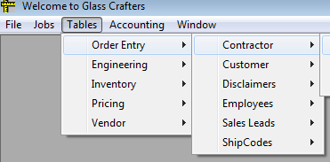
Contractor
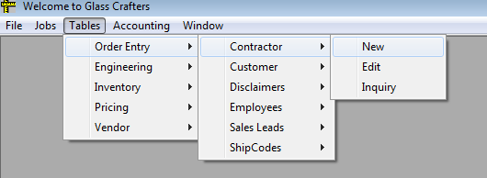
Invoked screens:
- New
- Edit
- Inquiry

Customer
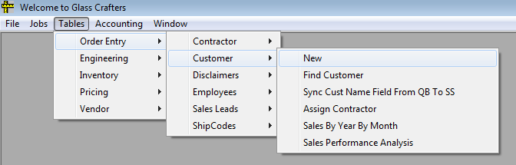
Invoked screens:
- New
- Find Customer
- Sync Cust Name Field From QB to SS
- Assign Contractor
- Sales By Year By Month
- Sales Performance Analysis

Disclaimers
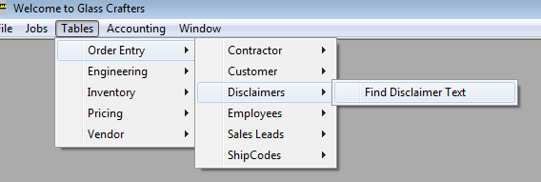
Invoked screens:
- Find Disclaimer Text

Employees
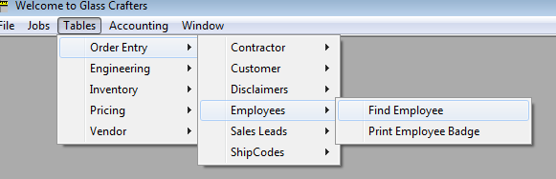
Invoked screens:
- Find Employees
- Print Employee Badge

Sales Leads
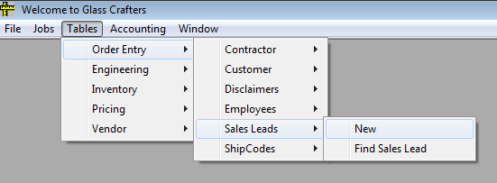
Invoked screens:
- New
- Find Sales Lead

ShipCodes
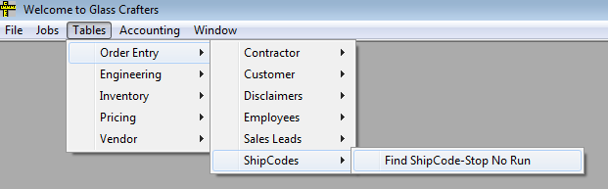
Invoked screens:
- Find ShipCode-Stop No Run

Engineering
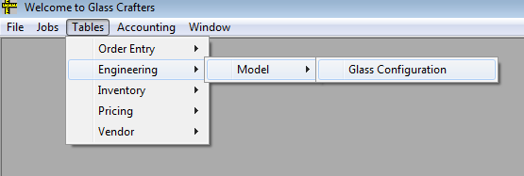
Invoked screens:
- Glass Configuration

Inventory

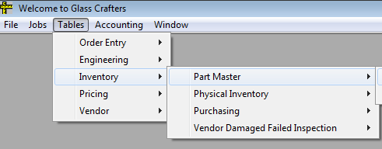
Part Master
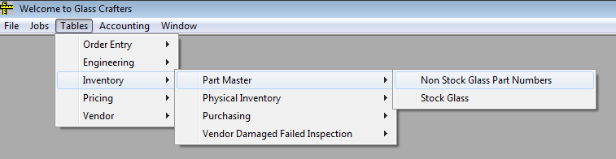
Invoked screens:
- Non Stock Glass Part Numbers
- Stock Glass

Physical Inventory
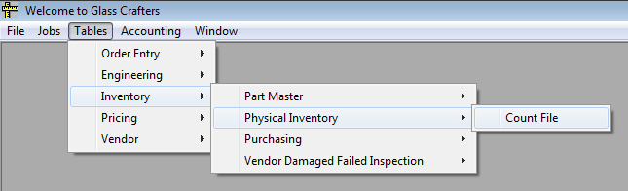
Invoked screens:
- Count File

Purchasing
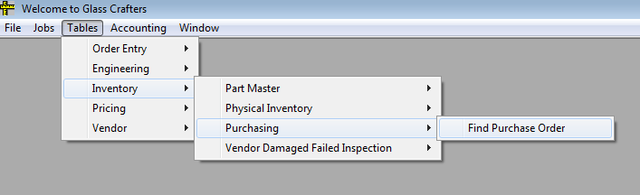
Invoked screen:
- Find Purchase Order

Vendor Damaged Failed Inspection
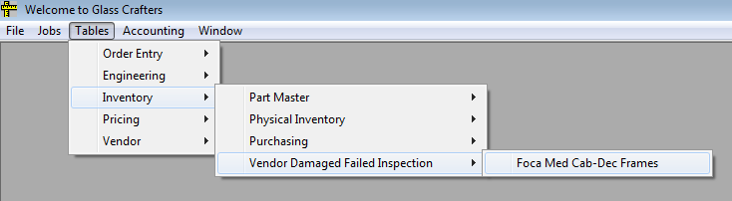
Invoked screens:
- Foca Med Cab-Dec Frames

Pricing
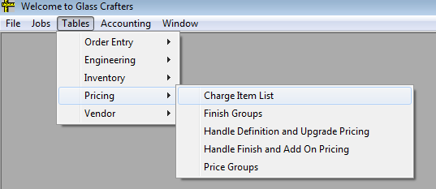
Invoked screens:
- Charge Item List
- Finish Groups
- Handle Definition and Upgrade Pricing
- Handle Finish and Add On Pricing
- Price Groups

Vendor
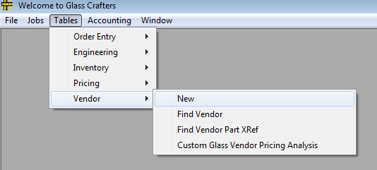
Invoked screens:
- New
- Find Vendor
- Find Vendor Part Xref
- Custom Glass Vendor Pricing Analysis

Accounting
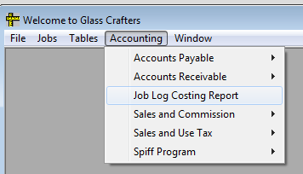
Invoked screens:
- Job Log Costing Report

Accounts Payable
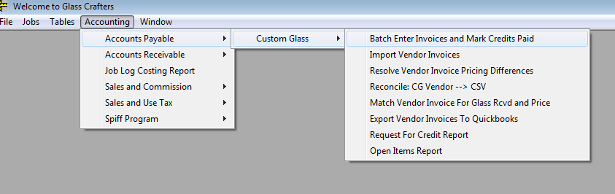
Invoked screens:
- Batch Enter Invoices and Mark Credits Paid
- Import Vendor Invoices
- Resolve Vendor Invoice Pricing Differences
- Reconcile: CG Vendor → CSV
- Match Vendor Invoice For Glass Rcvd and Price
- Export Vendor Invoices To Quickbooks
- Request For Credit Report
- Open Items Report

Accounts Receivable
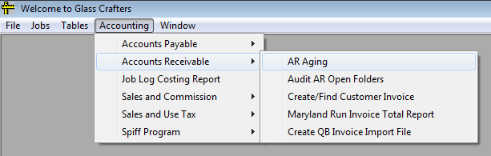
Invoked screens:
- AR Aging
- Audit AR Open Folders
- Create/Find Customer Invoice
- Maryland Run Invoice Total Report
- Create QB Invoice Import File

Sales and Commission
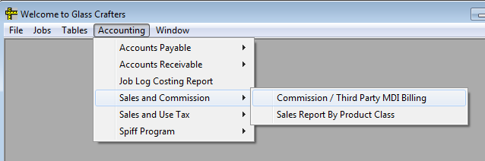
Invoked screens
- Commission / Third Party MDI Billing
- Sales Report By Product Class

Sales and Use Tax
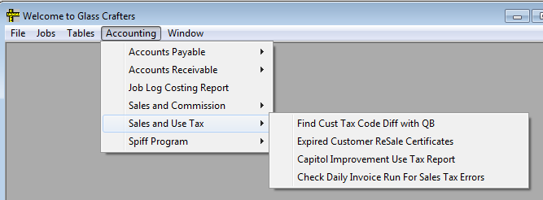
Invoked screens:
- Find Cust Tax Code Diff with QB
- Expired Customer ReSale Certificates
- Capitol Improvement Use Tax Report
- Check Daily Invoice Run For Sale Tax Errors

Spiff Program
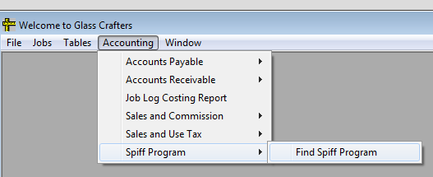
Invoked screens:
- Find Spiff Program

Screens

